TEMCO Wire Products Ltd

Policy

Sustainable and socially responsible actions secure

our company’s future.

for environment, occupational health and safety

TEMCO Wire Products Ltd is one of the World’s leading specialists of Nickel plated, Silver plated & bespoke Copper alloy wire products - our name is recognised globally with a reputation for high quality in our markets.

As a company that does business worldwide, we strive to harmonise our business success with responsible-minded conduct in relation to people, society and the environment. We are also fully aware of our responsibility in relation to global, long-term challenges such as climate change and the limited availability of primary resources.

With our clear goal of sustainable business development, we care- fully balance out economic, ecological and social requirements, and we face up to our social responsibilities by complying with

our own Code of Conduct. We offer our customers reliable, high- quality, environmentally-friendly products, which are manufactured in accordance with the relevant industrial health and safety regulations. We work continuously on improving the measures that are aimed at strengthening our social and ecological engagement. Our work is supported by internationally recognized management systems.

The principles behind our work:

• Social and ecological responsibility are core values.

• Occupational safety, health and environmental protection form part of all employees roles.

• Providing safe workplaces and working conditions that protect employee health by helping them avoid work-related injuries and illnesses.

• Continuous improvement of measures to improve occupational safety, and to protect health and the environment.

• Reducing the impact on the environment caused by our products and processes, where economically viable and technically feasible.

• Efficient use of environmental resources and energy.

• Prioritising waste avoidance over waste separation and disposal.

• Compliance with all obligations to uphold occupational safety, health and the environment (legal and other regulations).

• The relevant standards constitute our minimum requirements in this context.

• Creating and promoting mutual trust by engaging in dialogue with all interested parties, and internally with our employees and

their representatives in particular.

TEMCO Wire Products Ltd Management

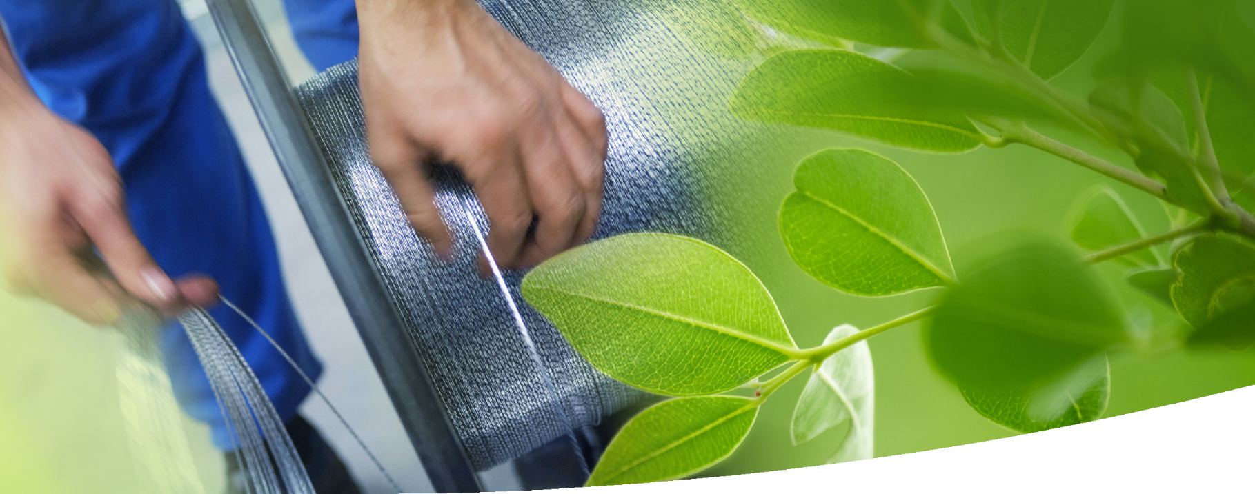

Cinderford, February 2024

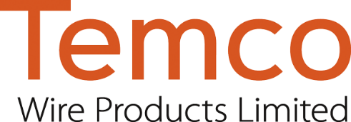

Brian Cutts Paul Rogers Sheena Cox Kerris Merkitt